Q.1. Sales of different TV Task 1: Write a MapReduce program to filter out the invalid records. The output of this program will act as input for subsequent tasks. Map only job will fit for this context.

Ans.

**Input File:**

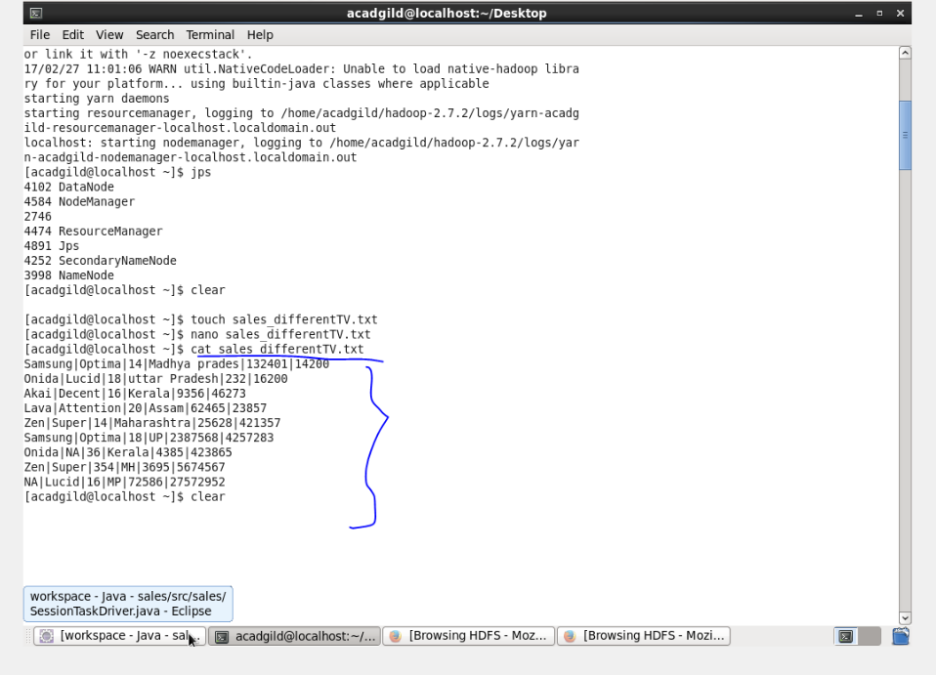

**Code:**

**Driver class**

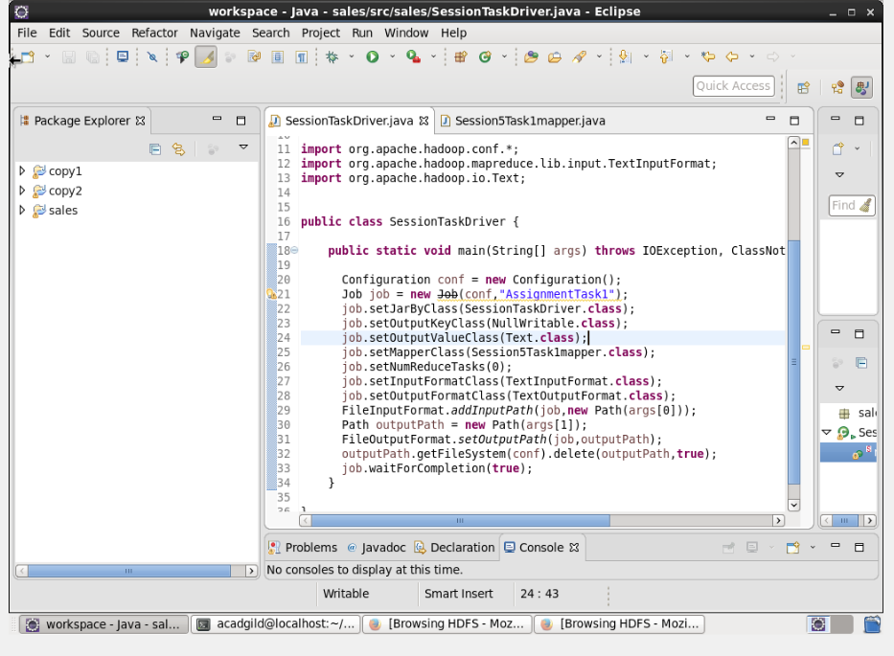

**Mapperclass*:***

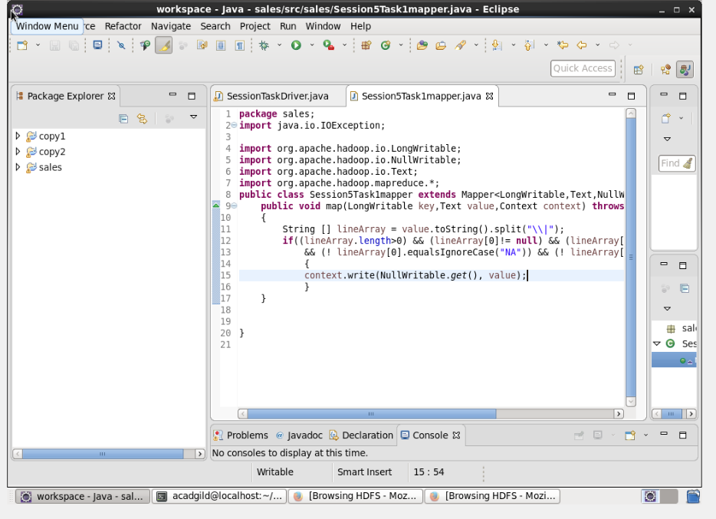

**Output:**

